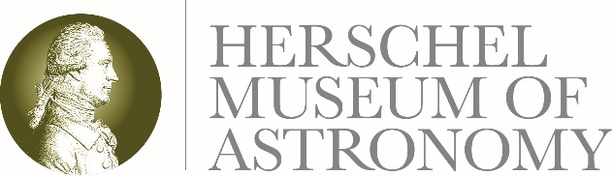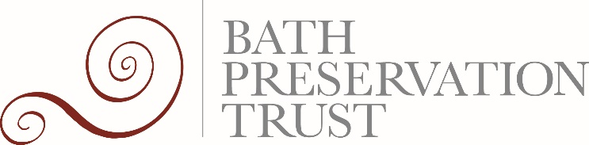

25 November 2019

It’s a win, win for the Herschel Museum of Astronomy as it picks up two awards at different ceremonies on the same night!

Bath’s Herschel Museum of Astronomy is no stranger when it comes to winning awards, but two on the same night is something of a record. As staff took to the stage in Bristol to collect the Gold award for best Small Visitor Attraction at the regional Tourism Awards, others were collecting a second place commendation at the Bath Live Business Awards for best Leisure and Tourism Business in Bath.

Caroline Kay, Chief Executive of Bath Preservation Trust which runs the Herschel Museum of Astronomy said:

“The Herschel Museum used to be considered a hidden gem in Bath, but not any more. It’s up there with the best of them now and we’re intensely proud of the staff and volunteers who have worked so hard to bring it to this level of recognition. That we won both a tourism award and a business award is testament to the way we reveal both the home and lives of brother and sister astronomers William and Caroline Herschel, seeing significant growth in visitor numbers and extending the offer while balancing the books on a tight budget.”

Earlier in the year the museum won a national Museums + Heritage Award for the best exhibition put on with a limited budget. The resulting exhibition, Wonder Women of Space in 2018 was a terrific celebration of some inspiring space heroines. This year the exhibition focusses on William Herschel’s innovative discovery of Infrared and how this science is benefiting futher explorations in space.

The Herschel Museum’s learning and engagement programme, including community projects and outreach work, has also been recognised with a 2019 Sandford Award for education excellence at an historic site.

-Ends-

For further information please contact: Janey Abbott, Communications Officer, Bath Preservation Trust. Telephone: 01225 338727 Email: jabbott@bptrust.org.uk www.herschelmuseum.org.uk

Notes for editors

The Herschel Museum of Astronomy, a Bath Preservation Trust Museum, is dedicated to the many achievements of the Herschels, who were distinguished astronomers as well as talented musicians. It was from this house, using a telescope of his own design that William discovered the planet Uranus in 1781. His observations helped to double the known size of the solar system. Following a tradition of the great astronomers of the Renaissance he pushed forward the science of building telescopes. He was rewarded for his work by King George III, and also received the Copley Medal. Caroline also made a huge contribution to the field of astronomy. The work of the Herschels clearly had an impact on modern science and space exploration.
The late Sir Patrick Moore was a patron of the museum and described William Herschel as “the first man to give a reasonably correct picture of the shape of our star-system or galaxy, the best telescope-maker of his time, and possibly the greatest observer who ever lived”. Our current Patron is Dr Brian May.
The museum is open until 1 January 2020.

Bath Preservation Trust, an amenity charity set up in 1934 to safeguard the heritage city of Bath and its surrounding green countryside, runs four museums in the city: No. 1 Royal Crescent, the Museum of Bath Architecture, Herschel Museum of Astronomy and Beckford’s Tower. The Museum of Bath Architecture received a Highly Commended in the same award category at the Bath, Bristol and Somerset Tourism Awards 2019.

@Herschelmuseum
#Herschelmuseum

