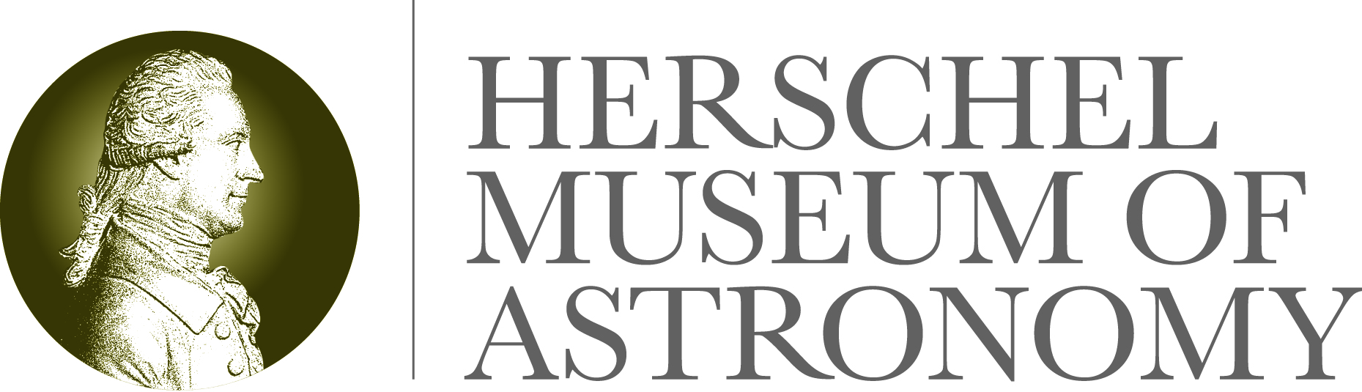
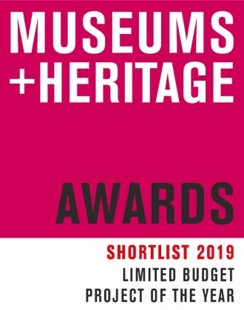

16 May 2019

The Herschel Museum of Astronomy’s Wonder Woman of Space exhibition wins Limited Budget Project of the Year at the

Museums and Heritage Awards 2019

Up against strong competition from the likes of National Museums Liverpool, University of Cambridge Museums and the Novium Museum, Bath’s Herschel Museum of Astronomy was last night announced as winner of the Limited Budget Project of the Year for its 2018 exhibition ‘Wonder Women of Space’.

The Museums and Heritage Awards celebrate best practice within museums, galleries and heritage visitor attractions across the UK. 14 awards are presented to honour innovative and ground-breaking initiatives from museums large, small, national or regional and from iconic buildings and monuments to the great outdoors.

The judges were looking for creativity in the face of challenges to the sector, originality and diversity of offer, engagement with the community and with business partners and impressive results. The Wonder Women of Space exhibition ran for nine months in 2018 and cost just £980 to put on. An associated programme of activites included space-themed workshops, star-gazing, school visits, talks and opportunities to meet international astronauts and scientists, and attracted visitors from all over the world. The Museum enjoyed a 31% increase in visitor numbers and 68% increases in followers on social media.

Collecting the award at the London ceremony hosted by cleric and broadcaster Reverend Richard Coles, Dr Amy Frost said:

“As Senior Curator of the Bath Preservation Trust, which runs the Herschel Museum of Astronomy and three other fantastic museums in Bath, to even to be part of such a distinguised shortlist was a great reward. To win feels fantastic! We’re over the moon at this level of recognition and can’t thank the judges enough for seeing how hard and creatively we worked on this exhibtion and programe of events. We’re a charity, receiving no external funding, and couldn’t have run this project without the £1,000 grant we received from our local authority. Thank you to them, to our dedicated and excellent museums team – and to those incredible female space scientists, past and present, who inspire us with their genius.”

Talking about the Wonder Women of Space Exhibition, Diane Lees CBE, Director General of the Imperial War Museums and Chair of the 2019 judging panel, noted: “The judges were impressed by the great return on investment this project achieved by cleverly linking to a specific object in its collection.”

The Herschel Museum of Astronomy’s 2019 exhibition is open and is titled Invisible Light: William Herschel and Infrared.

-Ends-

For further information please contact: Janey Abbott, Communications Officer, Bath Preservation Trust. Telephone: 01225 338727 Email: jabbott@bptrust.org.uk www.herschelmuseum.org.uk

Notes for editors
The Herschel Museum of Astronomy is dedicated to the many achievements of the Herschels, who were distinguished astronomers as well as talented musicians. It was from this house, using a telescope of his own design that William discovered the planet Uranus in 1781. His observations helped to double the known size of the solar system. Following a tradition of the great astronomers of the Renaissance he pushed forward the science of building telescopes. He was rewarded for his work by King George III, and also received the Copley Medal. Caroline also made a huge contribution to the field of astronomy. The work of the Herschels clearly had an impact on modern science and space exploration.
The late Sir Patrick Moore was a patron of the museum and described William Herschel as “the first man to give a reasonably correct picture of the shape of our star-system or galaxy, the best telescope-maker of his time, and possibly the greatest observer who ever lived”. Our current Patron is Dr Brian May.

Museums and Heritage Awards 2019
Shortlist for the Limited Budget Project of the Year
Wonder Women of Space Exhibition – Herschel Museum of Astronomy, Bath
“The Checks” Commemorating the Mining Communities of Kent – Studio Evans Lane as part of Historic England’s “Immortalised” exhibition
Chichester Roman Week 2018 – The Novium Museum
Happy Older People – National Museums Liverpool
Climate Hack – University of Cambridge Museums

